**Research Electronic Data Capture**

**REDCap**

**Training Outline**

**REDCap Version 5.2.3**

**Location:**

https://rcapdev.ouhsc.edu

**Overview:**

Logging in

OUHSC Username:

OUHSC Password

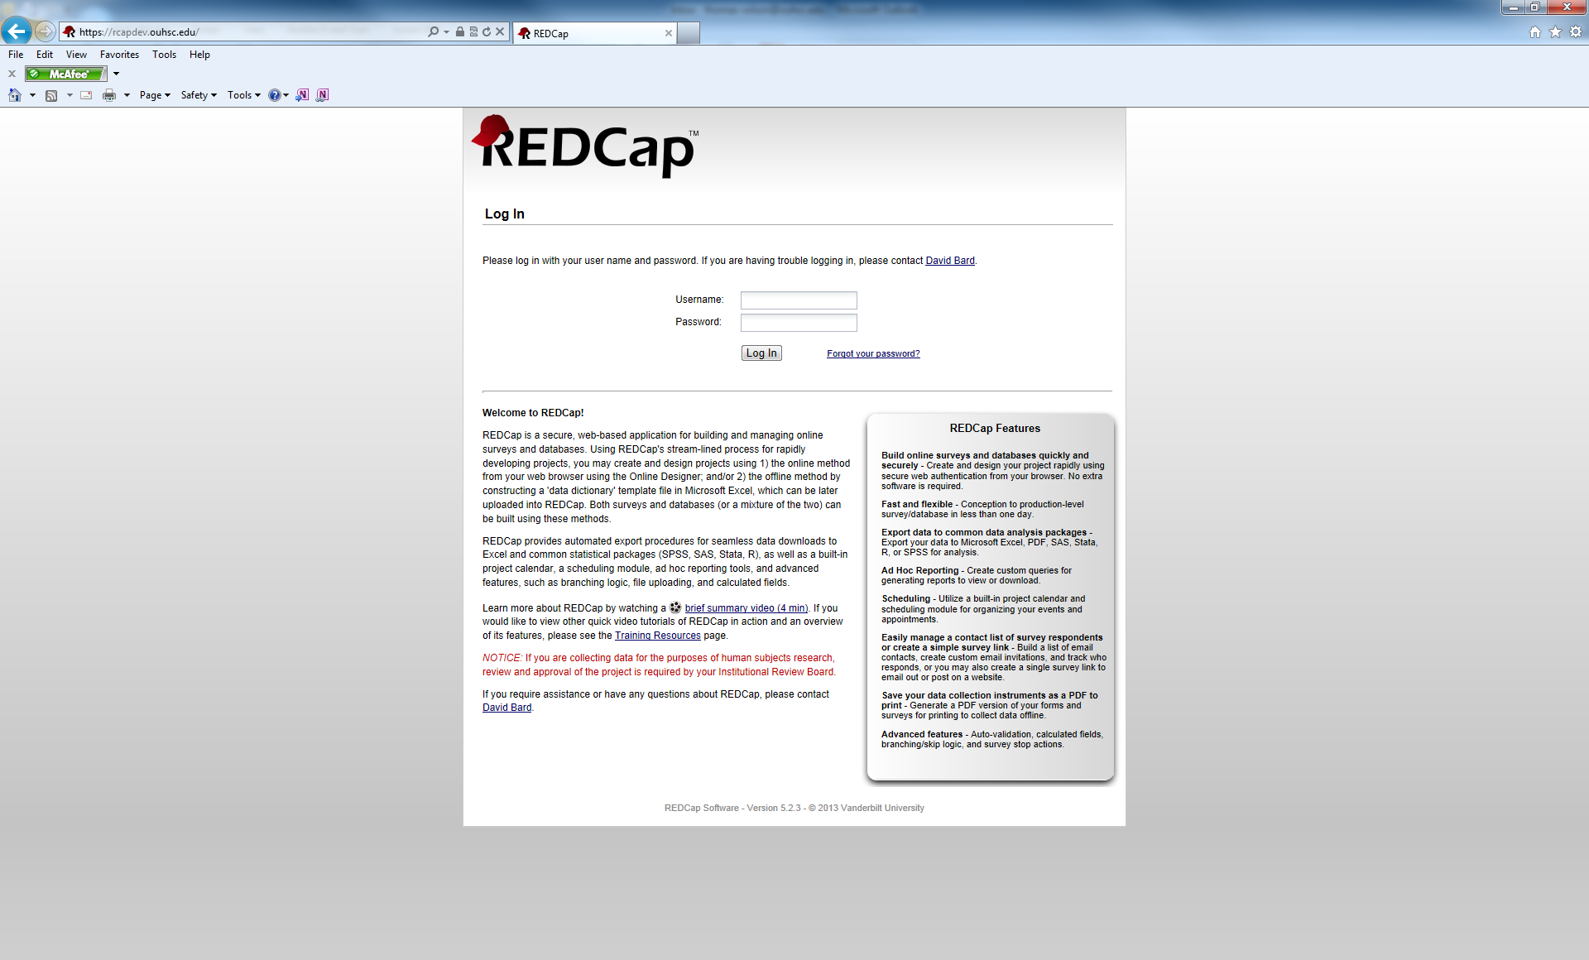

Main Menu Page

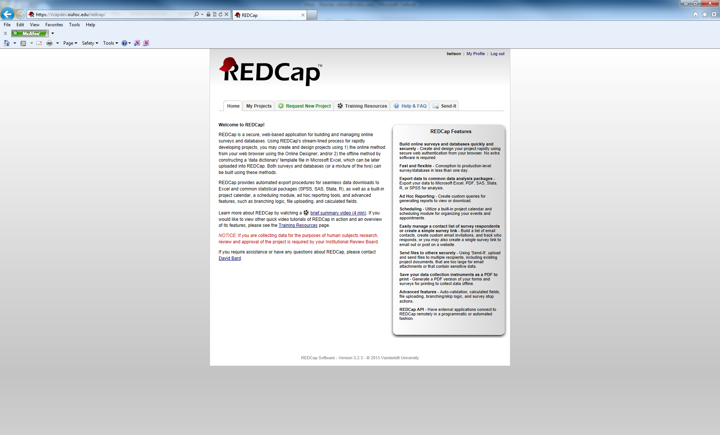

My Profile Hyperlink

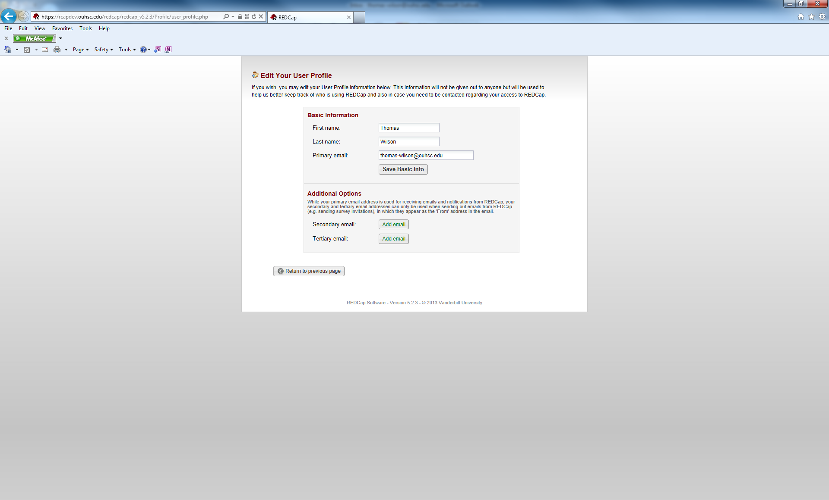

My Projects Tab

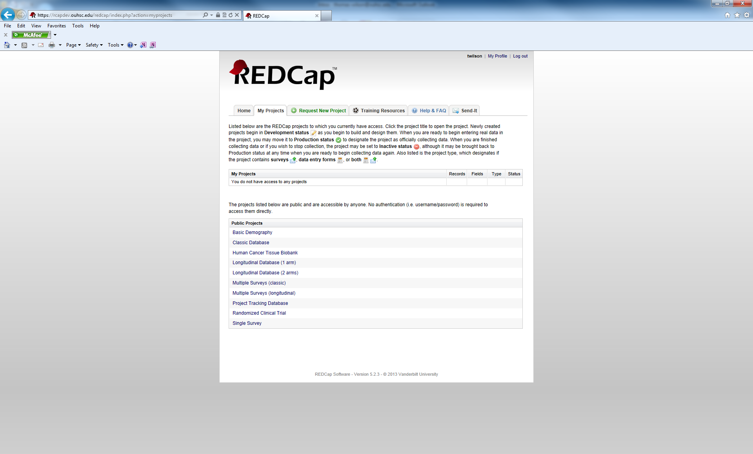

Request New Projects Tab

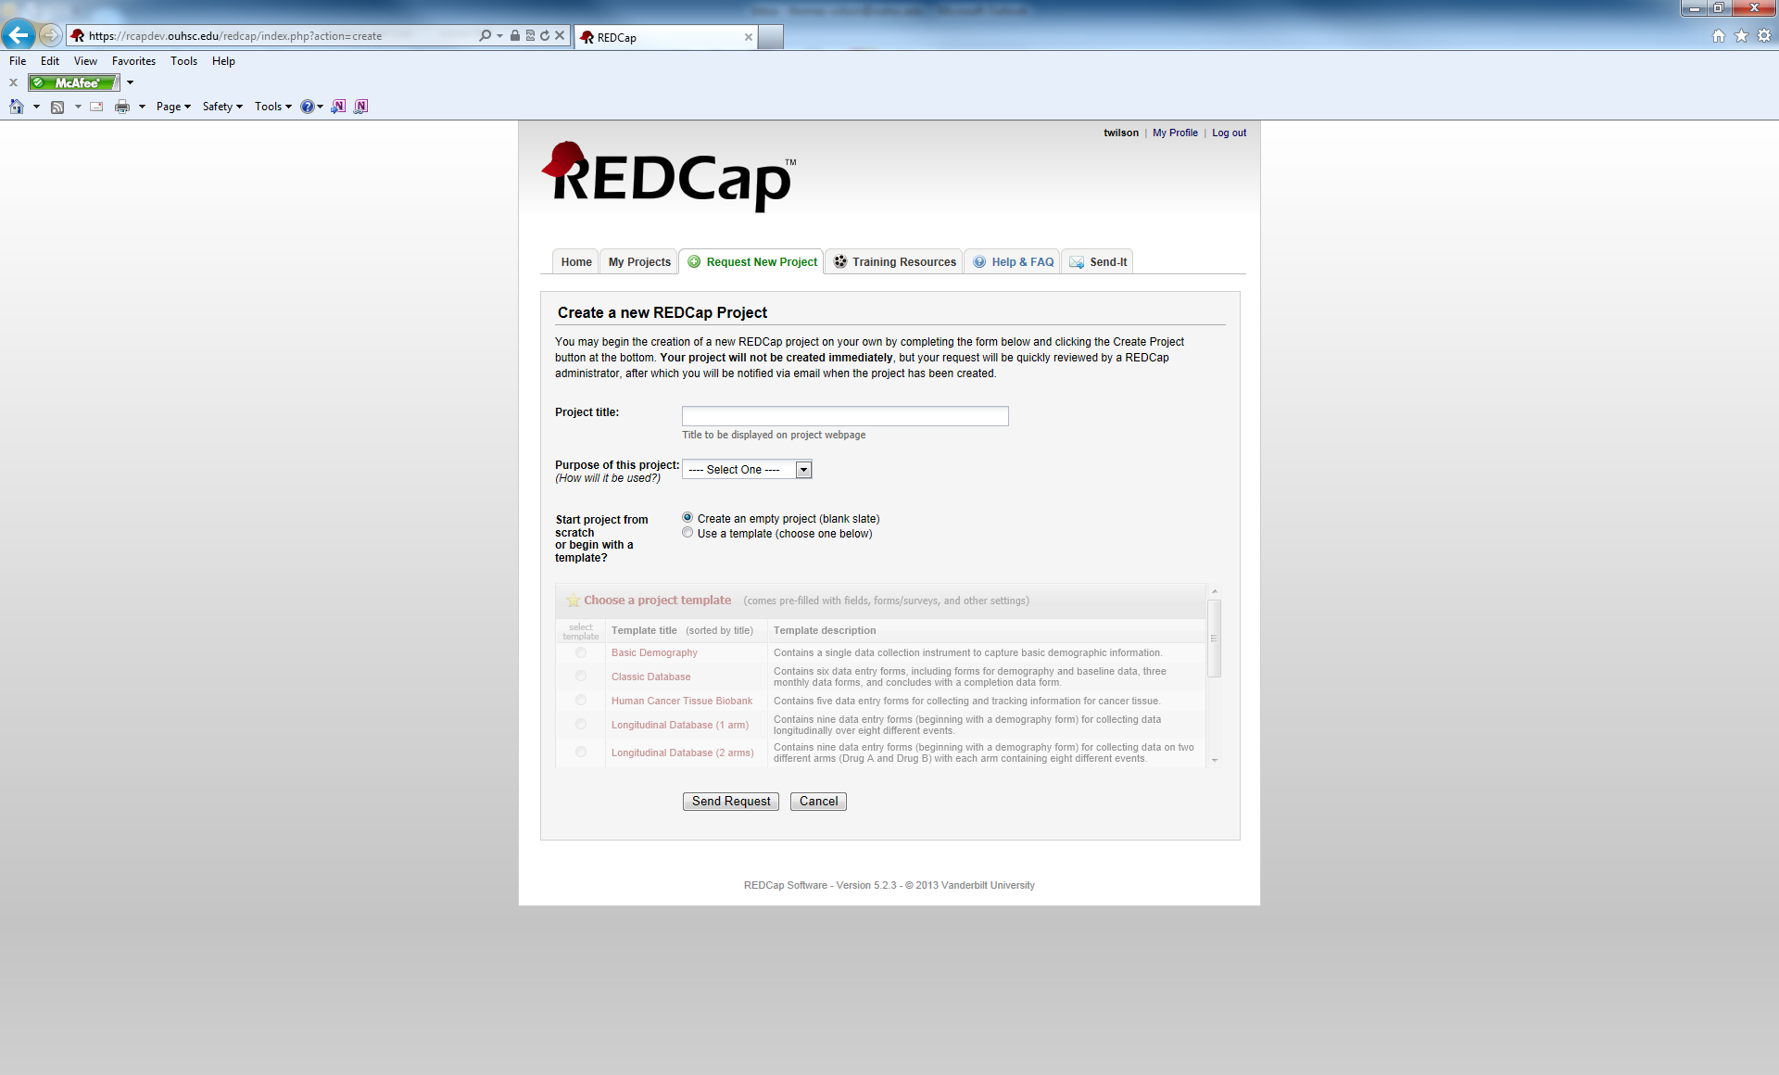

Training Resources Tab

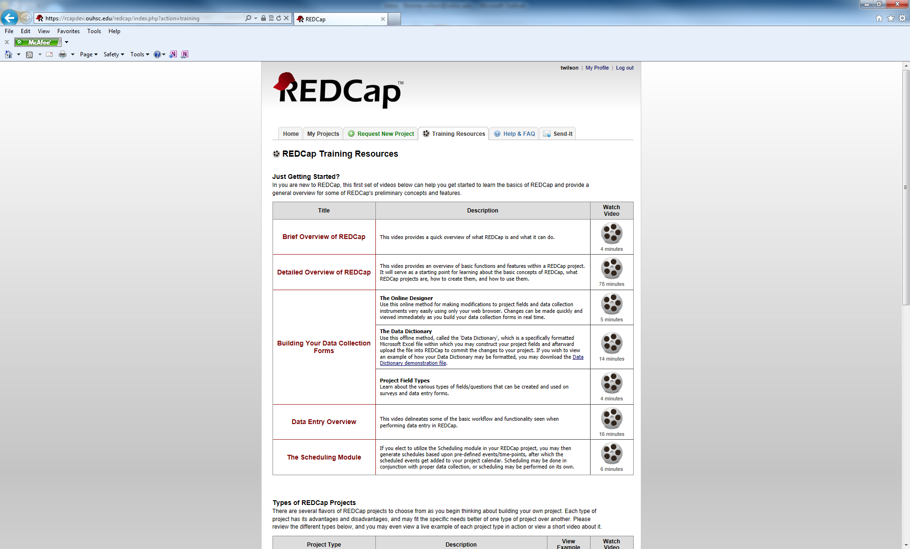

Help and FAQ Tab

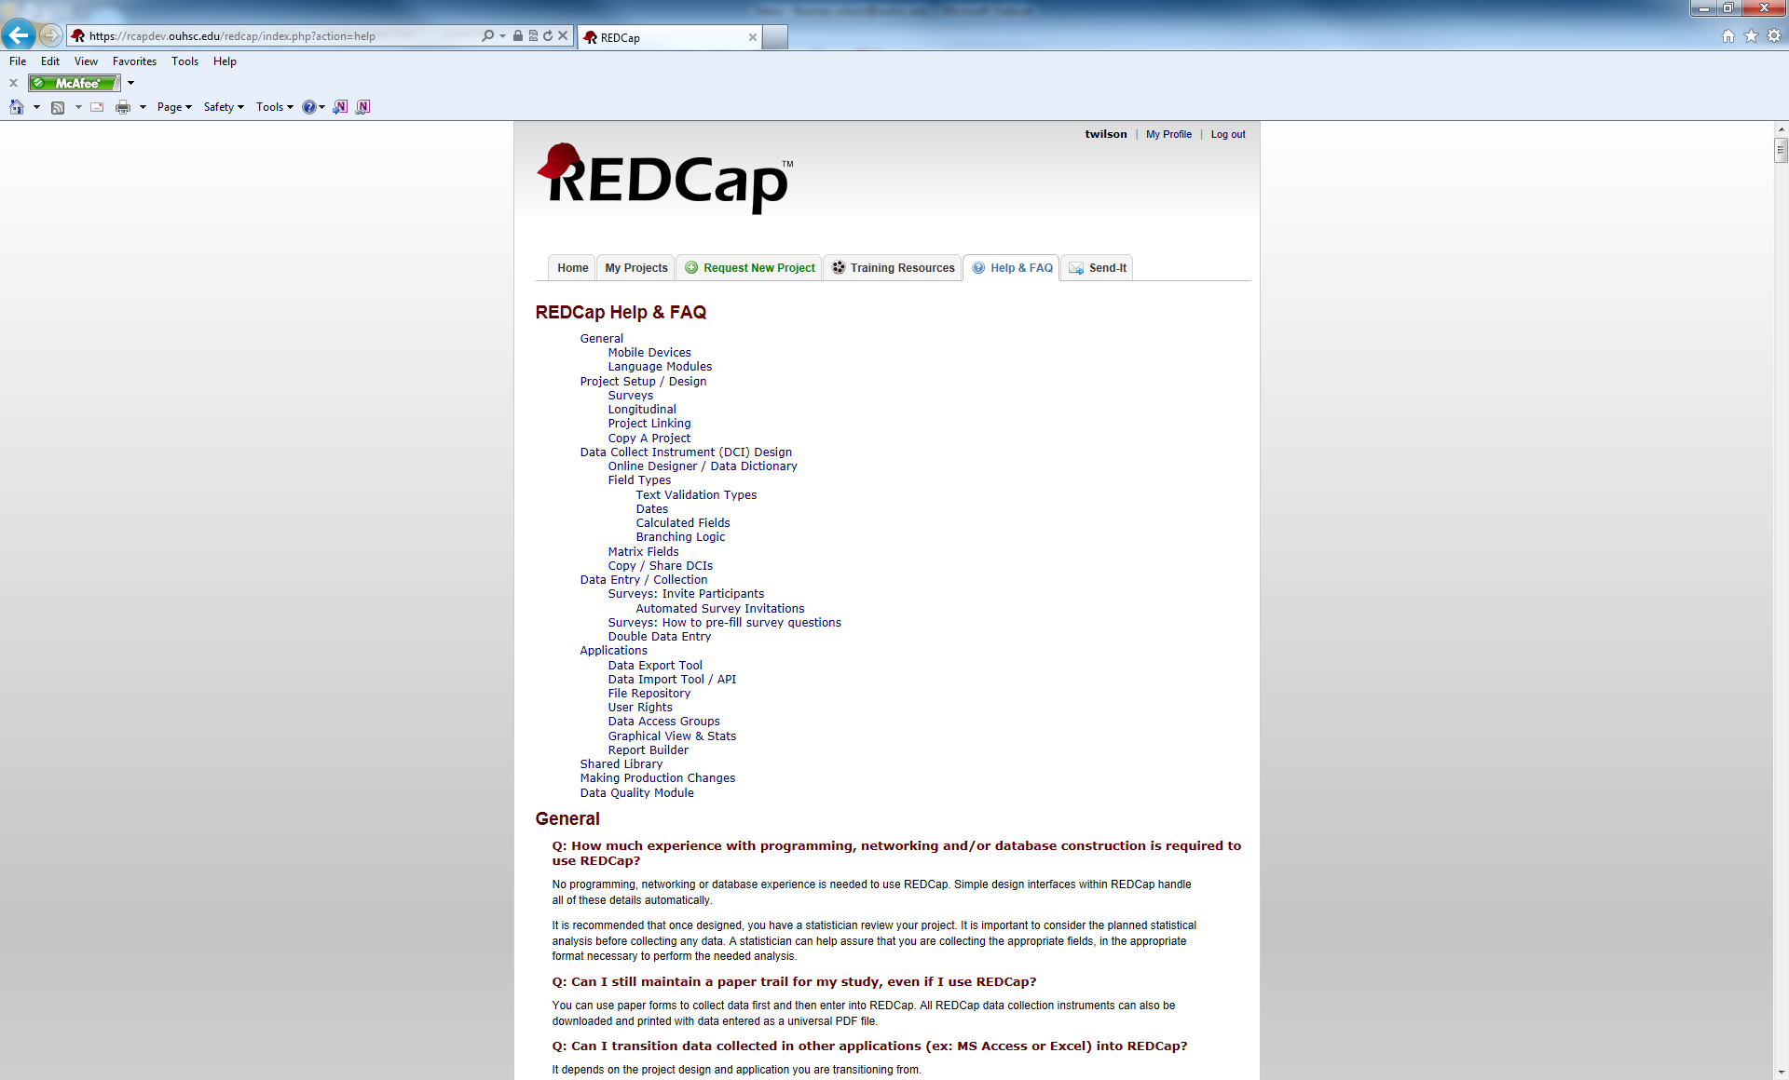

Send-It Tab

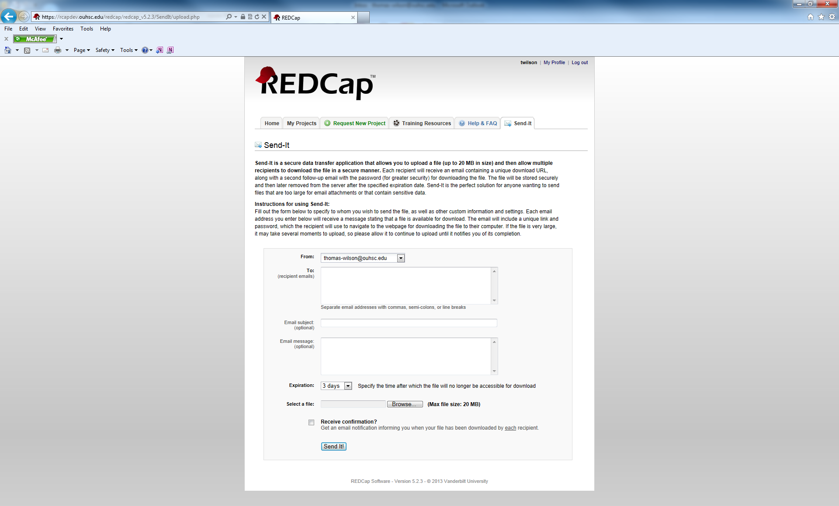

**REDcap Structure:**

REDCap is a browser-based, metadata-driven electronic data capture software. Programming, networking or database experience is not needed to use REDCap. It is designed to use simple interfaces that handle these details automatically. Before starting REDCap, it will be useful to be familiar with the terminology that REDCap uses.

**Project:** REDcap uses the term project to describe a set of data collection instruments that are store together for the same purpose. An analogous term to use would be a database.

**Development:** When a project is first created, it is in the development mode. In this status, changes are made with needing Superuser approval. Changes are also made in real-time. Real research data should not be stored in a project that is in the development stage.

**Production:** After a project has been created and is ready for actual data collection, it is moved to the production status. In this status, any changes/modifications must be approved by a Superuser.

**Survey:** A survey is one of the two types of data collection instruments that REDCap utilizes. You can have multiple surveys within a REDCap project. A REDCap survey can be e-mailed to individual participants where they are given unique “Private Survey URL’s” or a survey can be made public and a “Public Survey URL” can be posted on a website. Private surveys can only be filled out one time whereas, public surveys can be filled out multiple times.

**Form:**  A form is the other type of data collection instrument within REDCap. Its intended use is in a clinical setting where a researcher enters the data into REDCap. Multiple forms can be used in a REDCap project.

**Longitudinal Data Collection:**  When conducting a longitudinal research study, REDCap allows you to designate a form or multiple forms to be used several times in a project.

**Events:** An event maybe a temporal event in the course of your project, such as a participant visit or a task to be performed. You can define the same events over the different arms of a project or you can define different events for each arm. After your events are defined, you then designate which data collection instruments you want to use for each specific event.

**Data Dictionary:** The data dictionary is an Excel .csv file that contains the design of a project. It can be uploaded into REDCap to expedite the creation of a project. It is quicker than creating a project using the web-based designer, but it does require more experience to use.

**Creating a new project:**

Click on the Request New Project tab in your main menu.

Give the project a title.

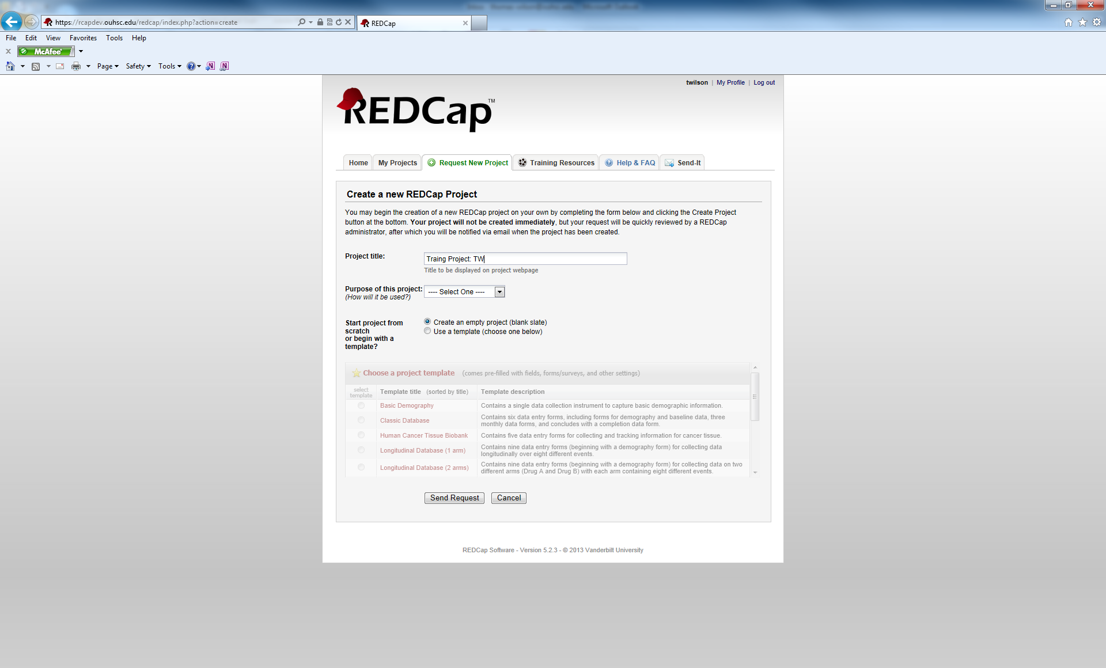

Select the purpose of the project.

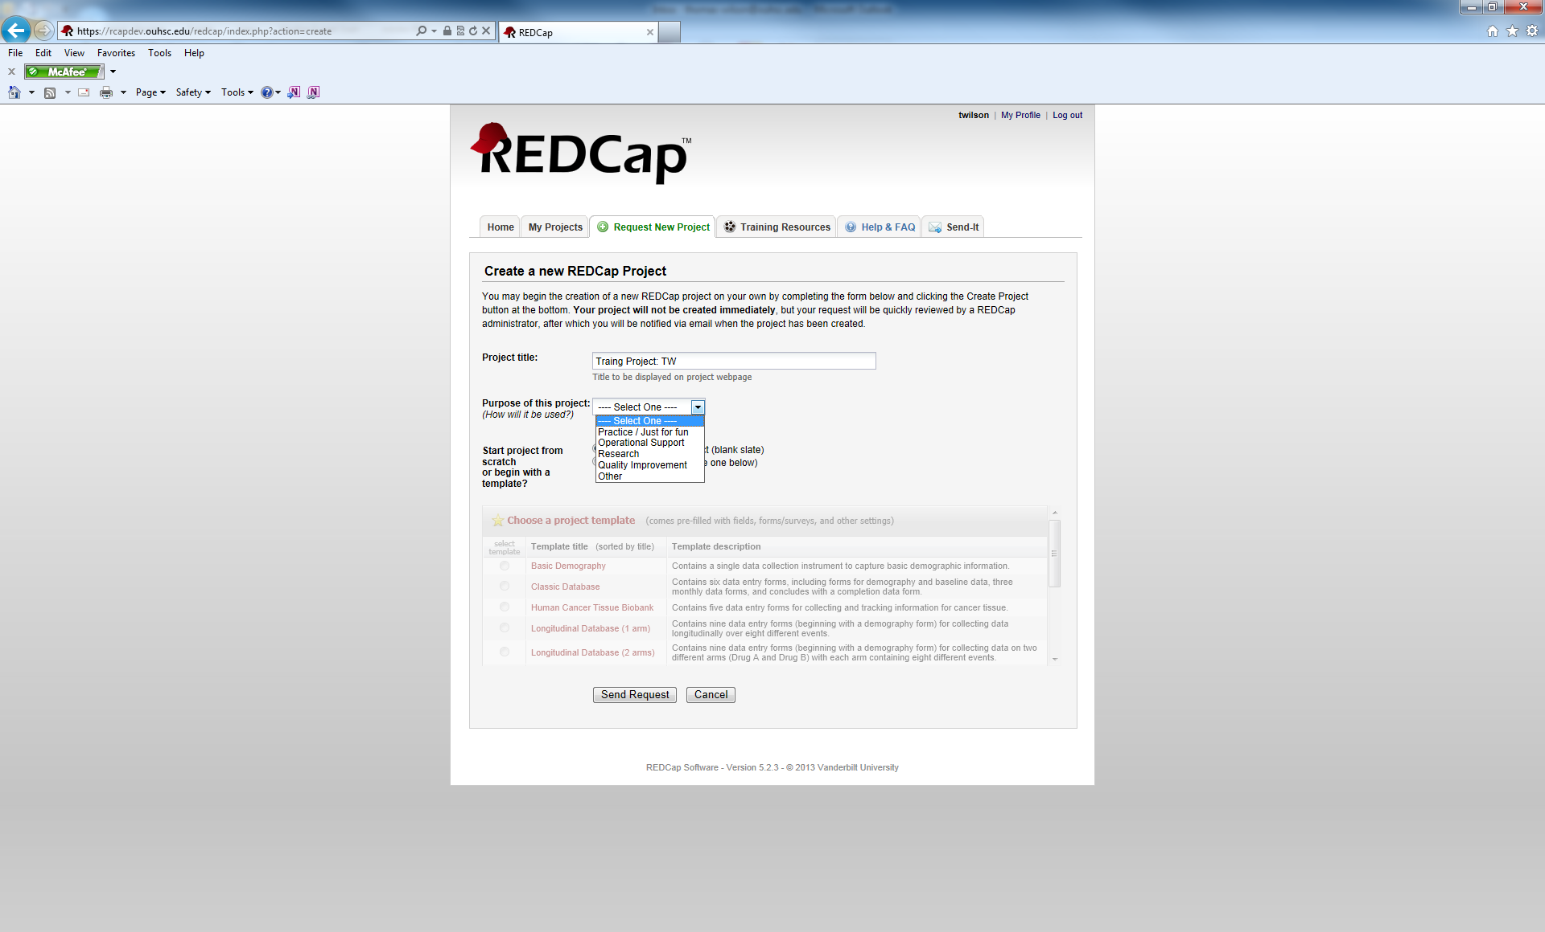

Choose whether or not you want to Create an empty project (you will be starting from scratch) or Use a template. For now, we will Create an Empty project.

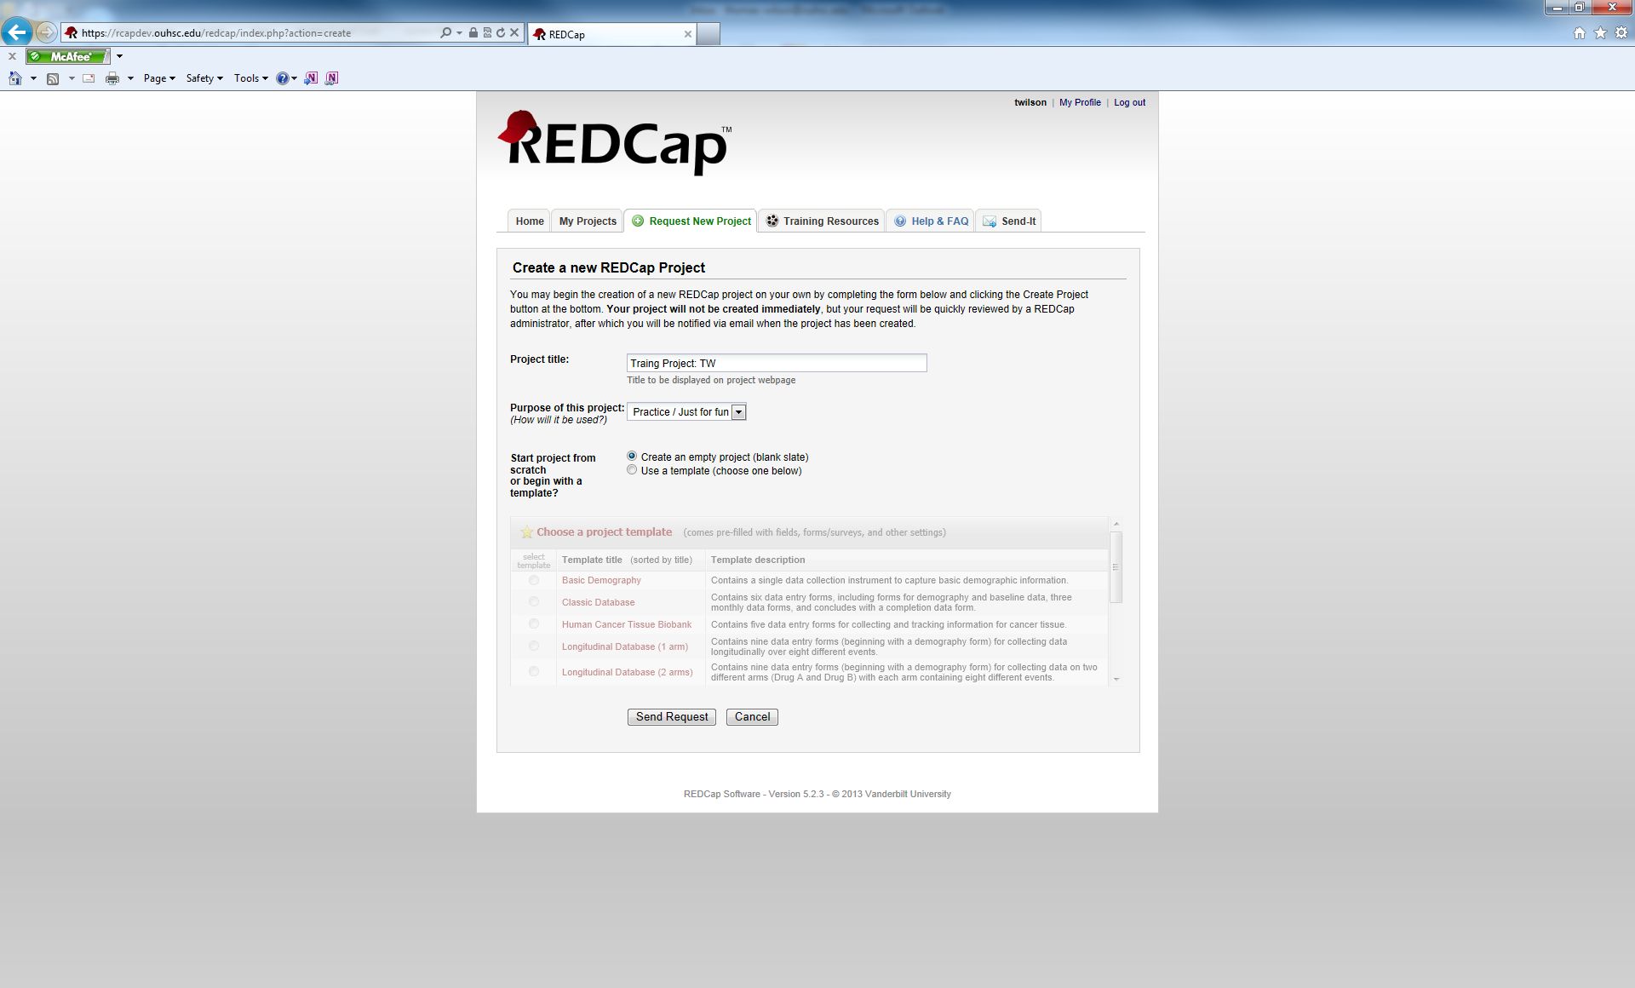

Click on the Send Request button.



You will get a message about the project needing to be approved.

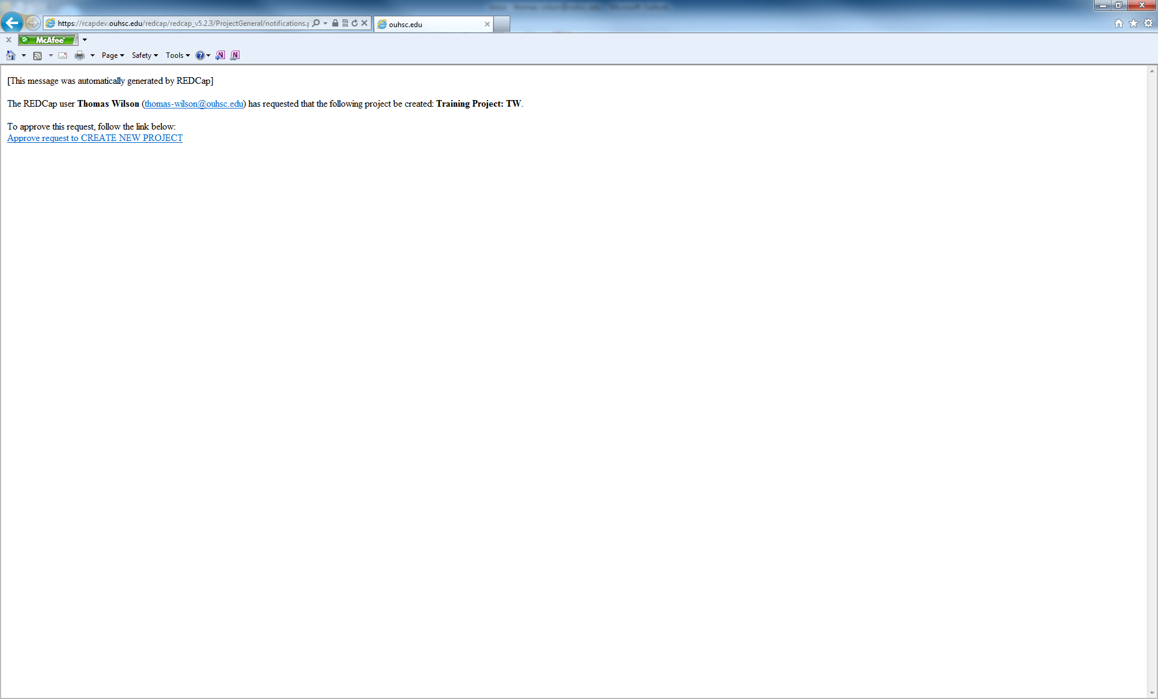

Once it is approved you will get a confirmation e-mail that looks something like this:

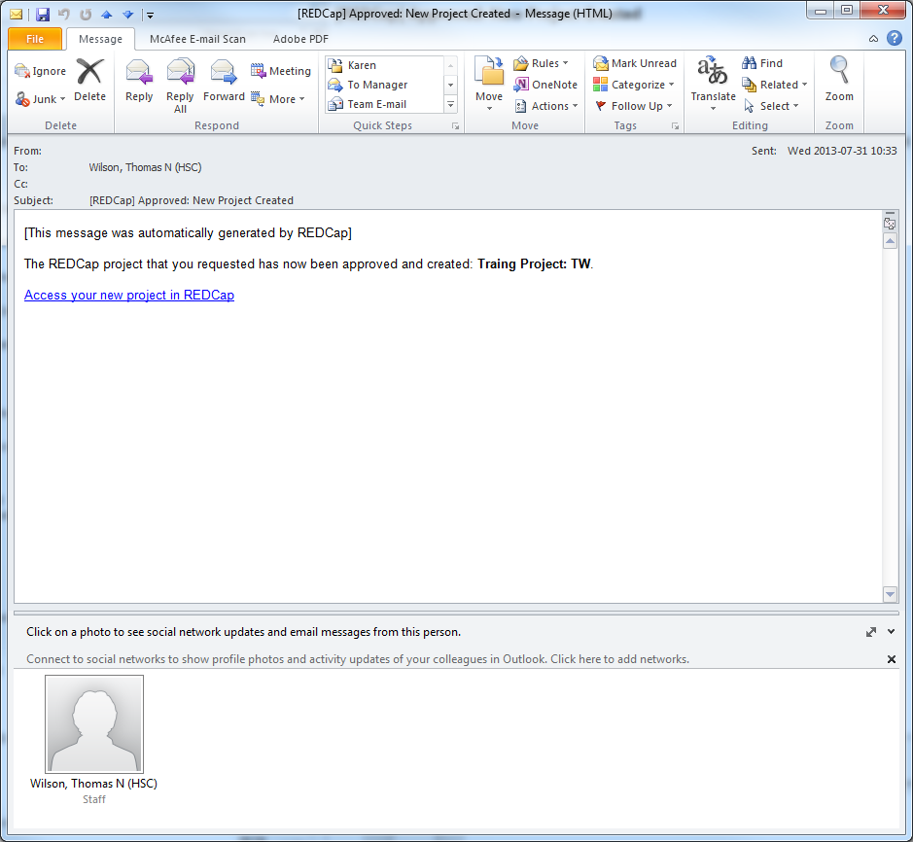

Once your access your project you will see the Project Menu screen.

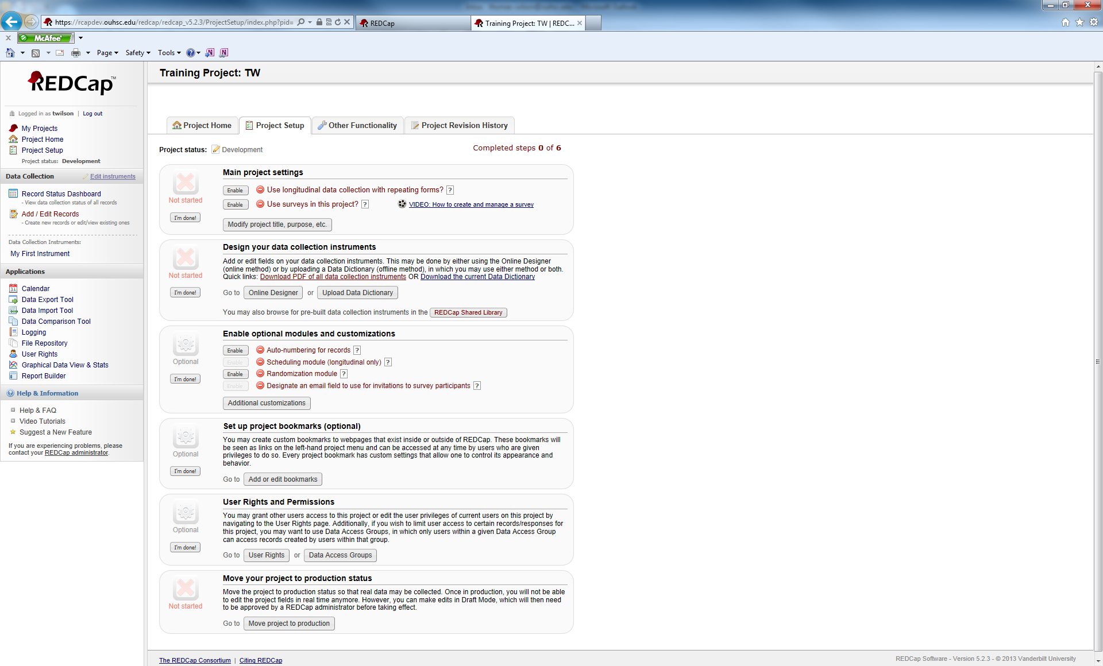

To begin the initial construction of your project, we will start with the Project Setup tab:



The Project Setup tab follows a linear format. Start at the top and work your way down to the bottom. If you wish, you can skip sections. You can also re-visit a section once you initially complete it.

We are going to start with the Main projec t settings section.



First, we will click the Modify project title, purpose, etc. button.



It will bring up the following pop-up window: You can change the Project Title and/or the Purpose of this project.

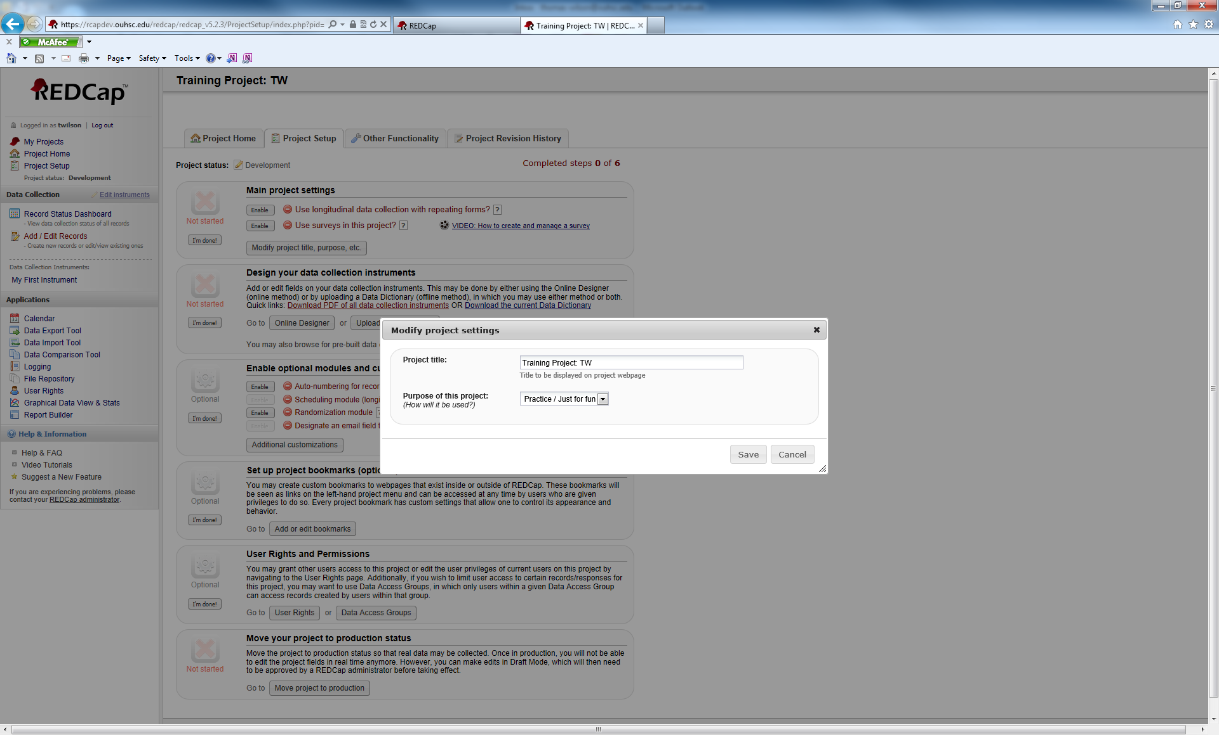

Make modifications, if any and you will return to the previous screen.

Next, you need to decide if your project is going to be longitudinal. If so, you will click the Enable button.

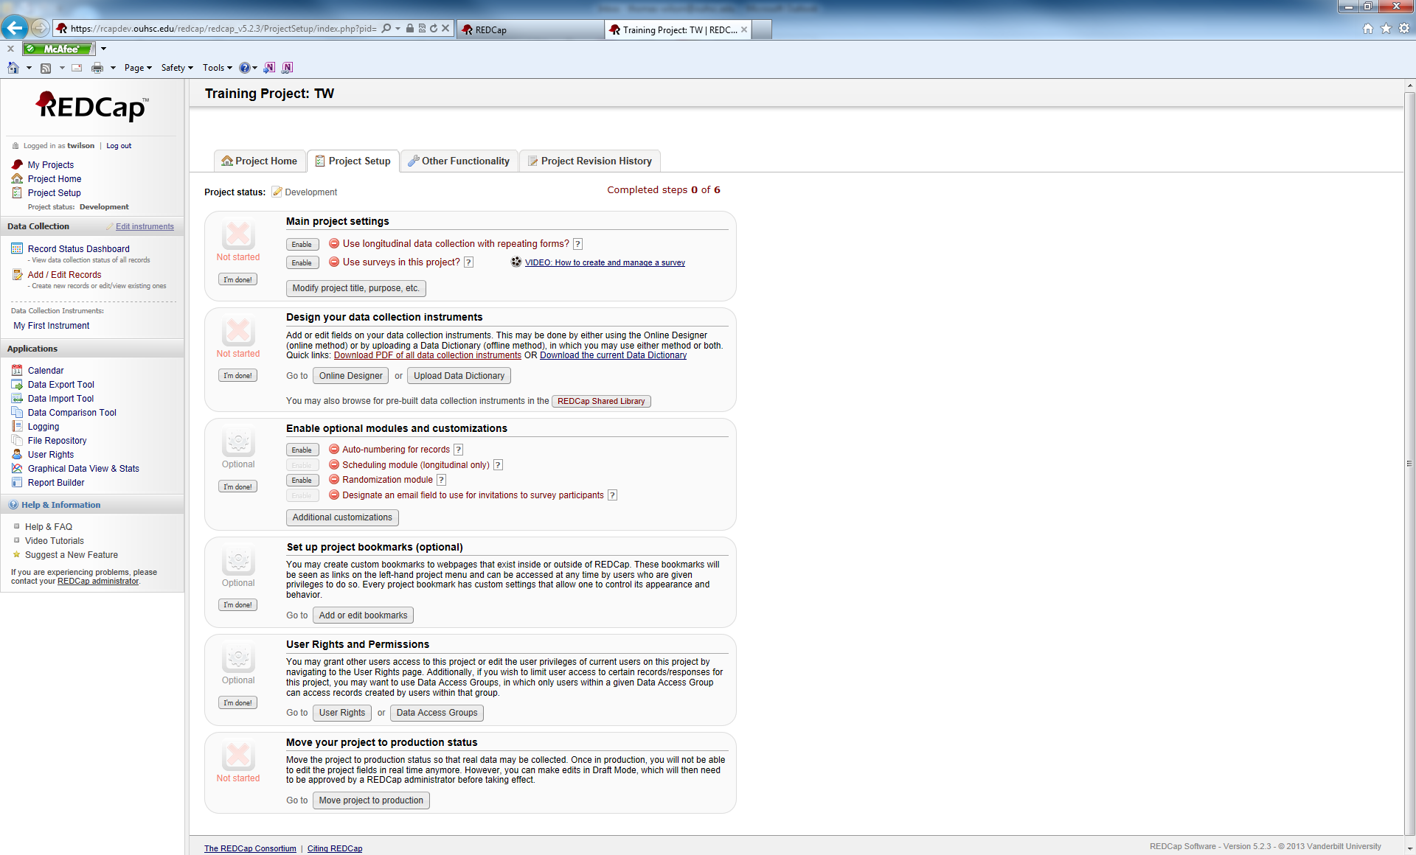

If you choose this option, your Project Setup screen will reflect that change.

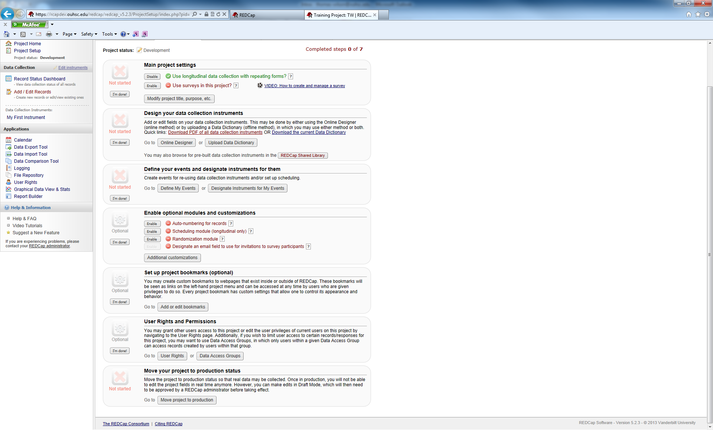

After this, you will determine if you want to enable surveys. If so, click the Enable button.



Again, if you enable this feature, your Project Setup screen will reflect that change.

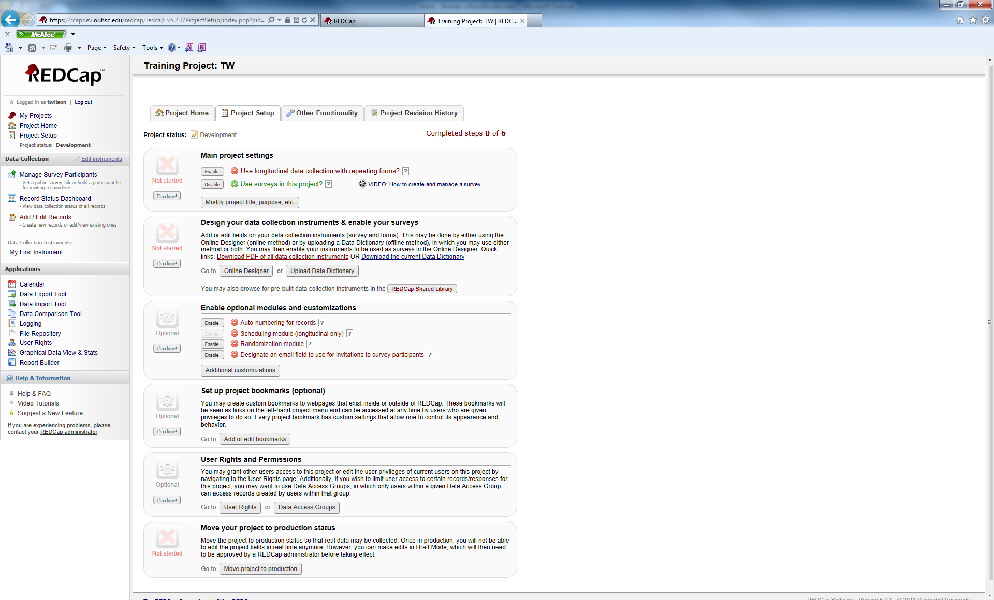

Once you have completed this section, you can click the I’m done! button in the left hand side of the project.

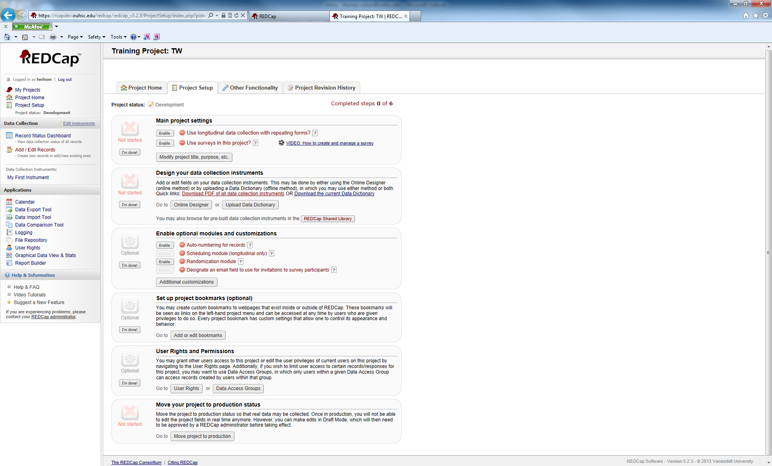

Once you have done that, your screen will look like this:

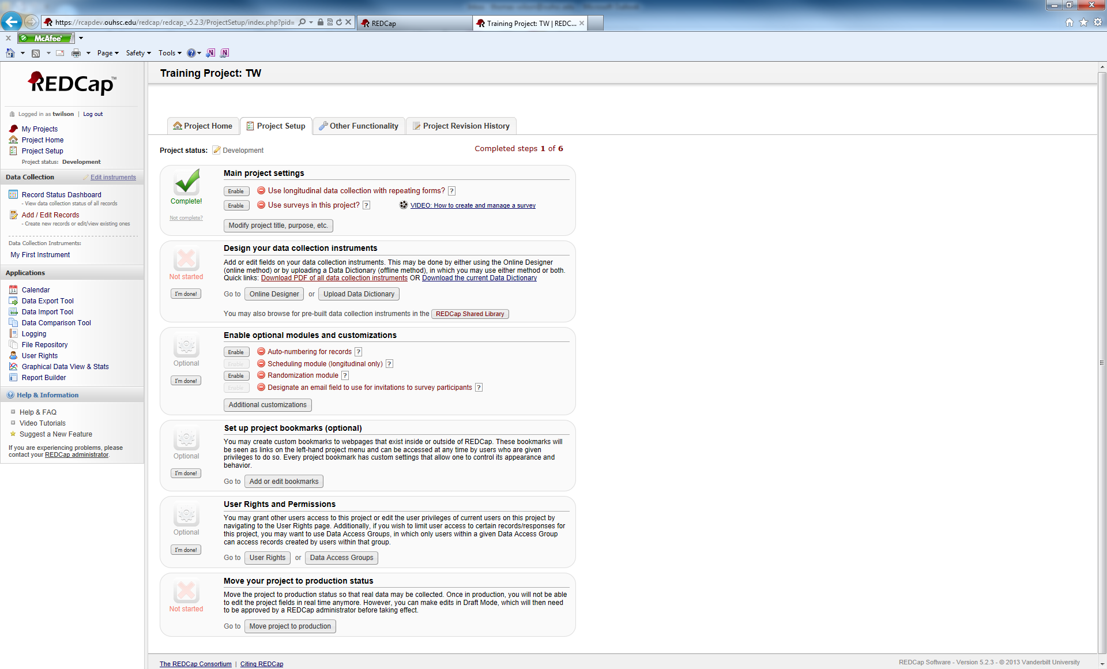

As with most features inREDCap, if you decide that you are not finished with this section, you can click on the Not complete? message underneath the green complete checkmark and change it back.

For now, we are going to work with a non-longitudinal project that is not using surveys. Make sure that in Main Project settings both the longitudinal and surveys options are not enabled.



Using the online designer, we are going to begin designing our data collection instrument.



Clicking the online designer button shows this screen:

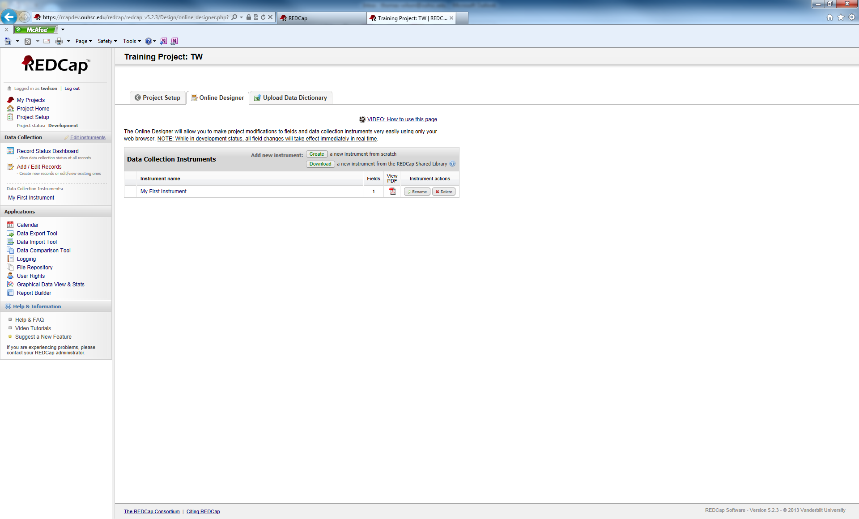

This will show you all of the Data Collection Instruments (DCI) that are in your project. In a new project, you have one default DCI named “My First Instrument”. It is doubtful that anybody would want to use that as an actual DCI name in a real project, we need to rename the DCI. Click the Rename button.



This will open up a text box where the DCI name is located. You can change the name now.

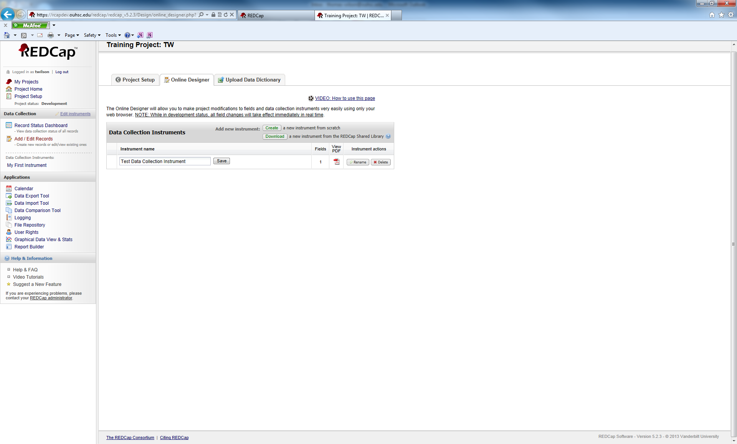

The name has been changed to Test Data Collection Instrument. Click Save to keep your changes.



Your DCI has been renamed. Now, we can make modifications.

The nameof the DCI is hyperlinked. Click on the DCI name.

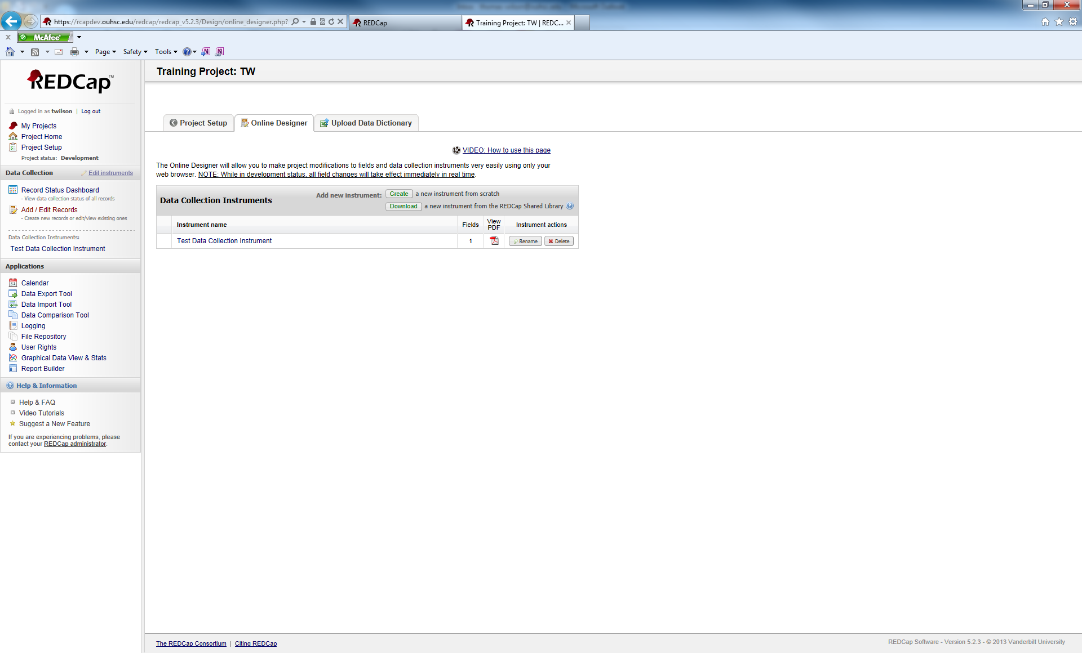

You will see the following screen.

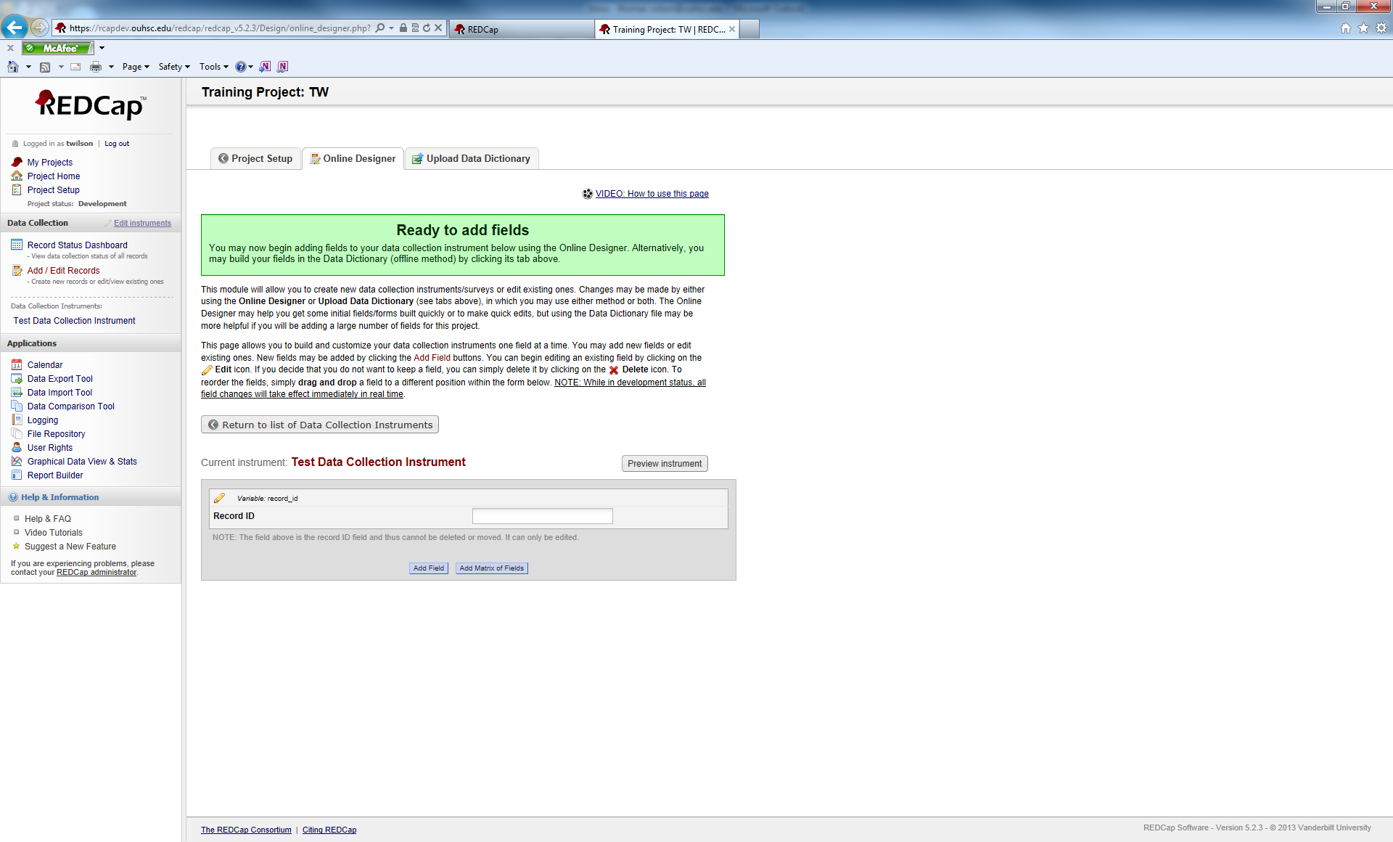

Note, you already have one variable in your DCI. Its field label is Record ID and the actual variable name is record_id. You cannot delete or move this variable. You can change its name. Common options include, participant_id, recruit_id, patient_id, etc.

We are going to add a field. Click on the Add field button.

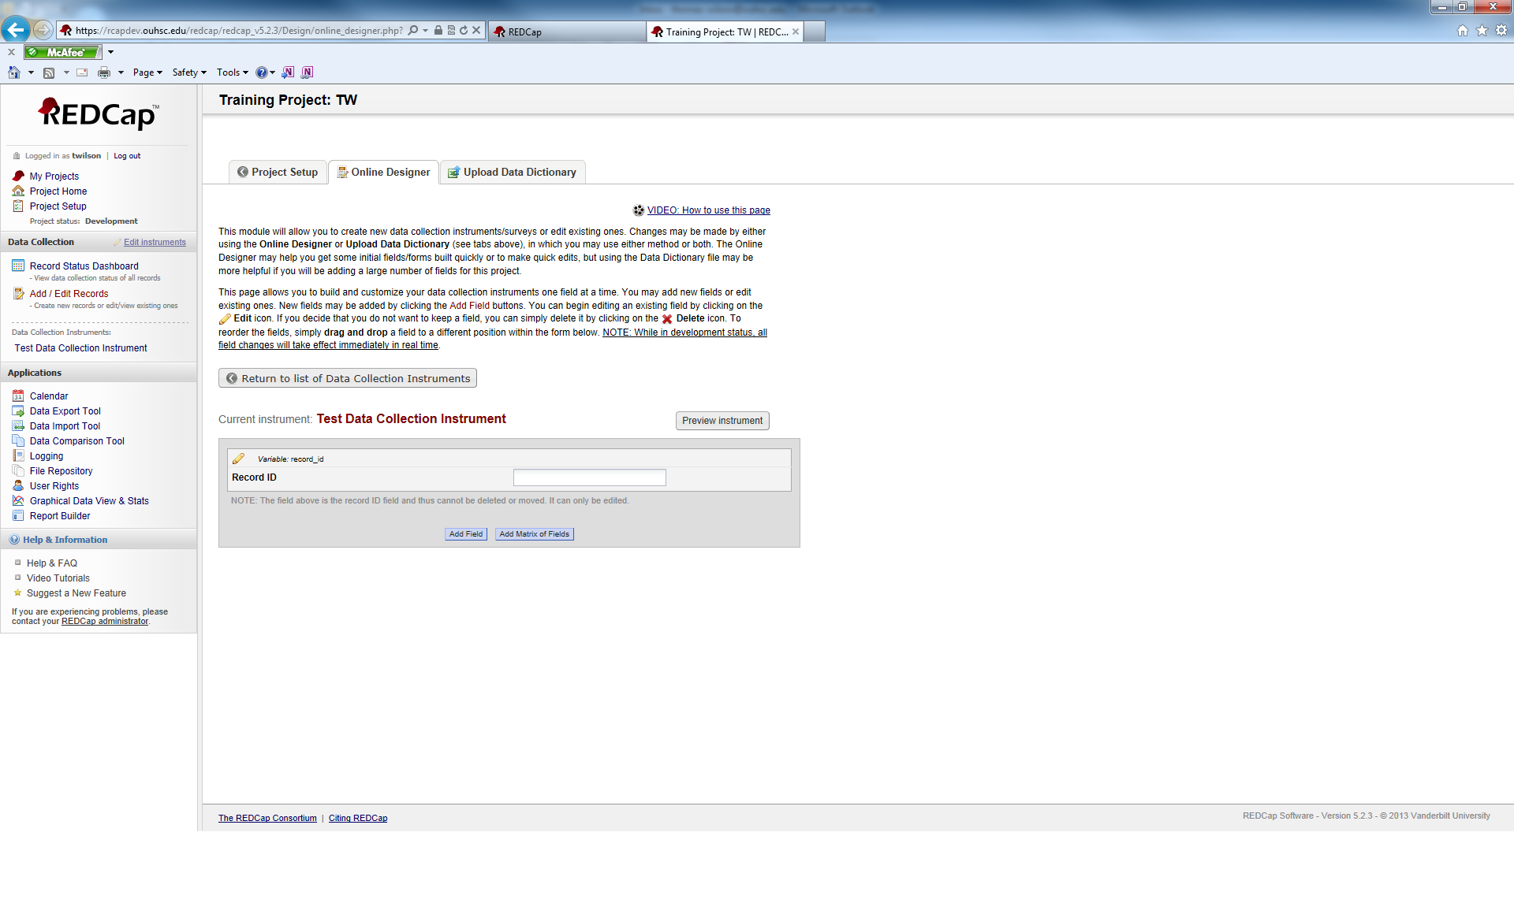

You will see the following pop-up window.

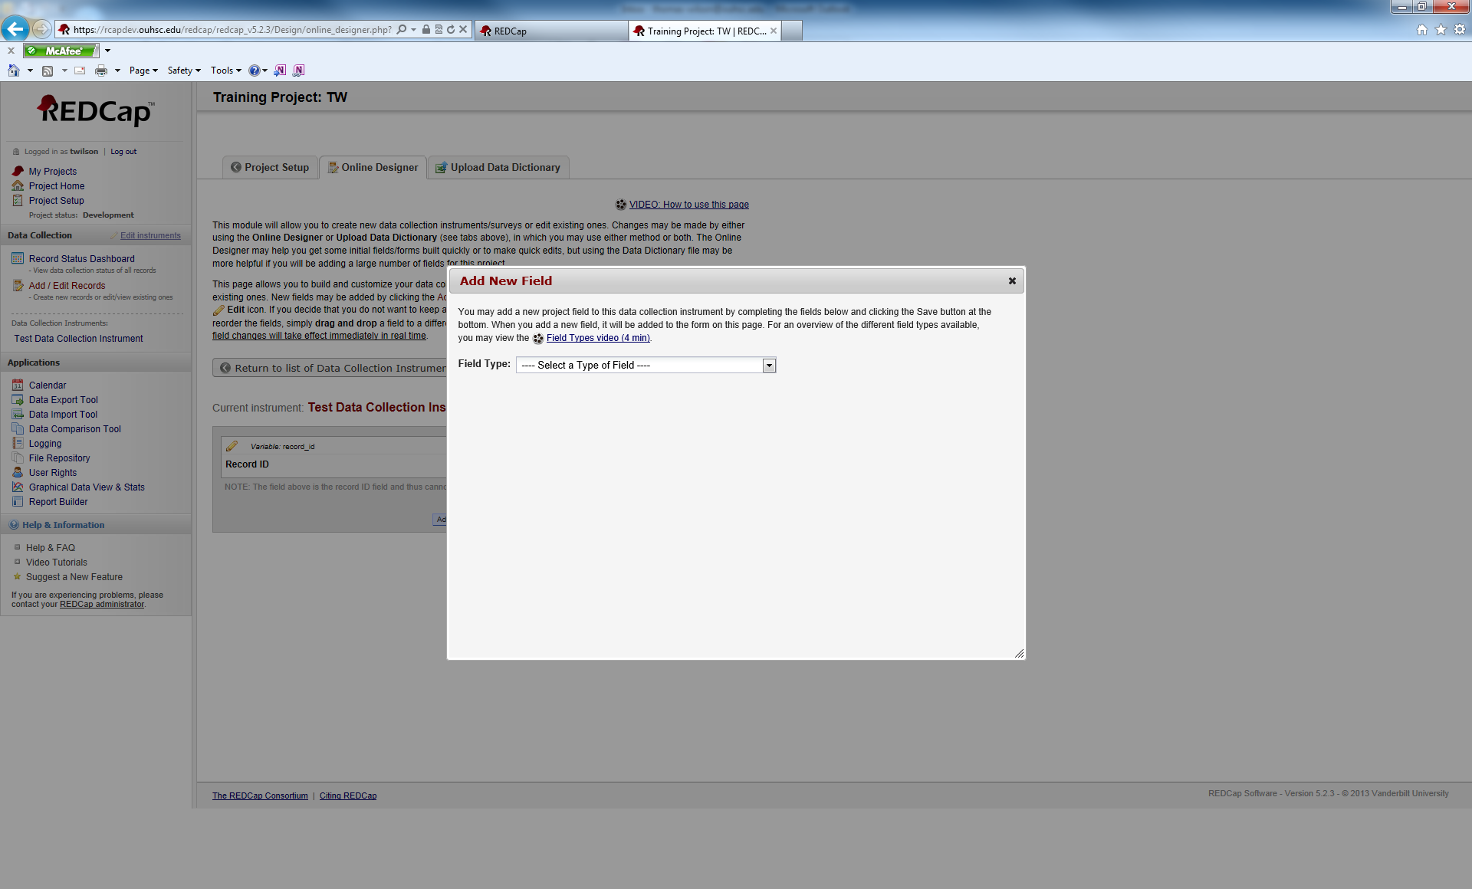

We need to select a Field Type:

Click the arrow for the drop-down menu.



Doing this will reveal all Field Type options.

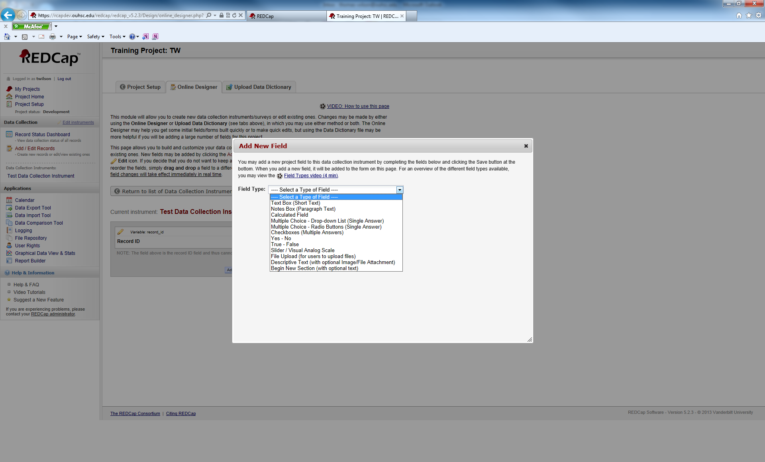

Available Field Types are:

Text Box (Short Text): Use this variable for free response items that have shorter response. Common uses of this variable include: name, address, phone, number, etc.

Notes Box (Paragraph Text): This variable is used for free response items that have a longer response. Response length is virtually unlimited even though the viewing window has a limited size. Common uses of this variable include: Please describe, in detail, any medical problems you are experiencing; Researcher Notes; etc.

Calculated Field: This variable is used to perform calculations on variables. It is limited to calculations on numeric variables only. You can use logical operators. For more information about calculated fields, look at the REDCap FAQ in the main menu screen.

Multiple Choice – Drop-down list (Single Answer): This is for multiple choice items. It creates a drop-down list of available response options. Only one answer can be chosen.

Multiple Choice – Radio Buttons (Single Answer): Similar response type as the drop-down list, except it uses circular buttons that an individual clicks on to select the answer. Again, only one answer can be chosen.

Checkboxes (Multiple Answers): Gives a list of response options. Users are shown square boxes to click in and any number of the response options can be selected. Used in a “Select all that apply” situation.

Yes-No: A multiple choice radio button answer that automically gives you the Yes and No options.

True-False: Same as above, except true/false

Slider/Visual Analog Scale: Creates a clickable sliding scale for users to rate an item from 0 to 100.

File Upload (for users to upload files): Users can upload pertinant documents/files as a response. It can be used to upload documentation (consent forms), scans of x-rays, etc.

Descriptive Text (with optional image/file attachment): This variable does not record any data. It is used as an informative text field to give users warnings, message, or instructions.

Begin New Section (with optional text): Again, this variable does not record any data. It creates a break in between sections in a form. It shows up in a different color.

In our Test Data Collection Instrument, we are going to create one of each type of variable. First we are going to select the Text Box (Short Text) option.

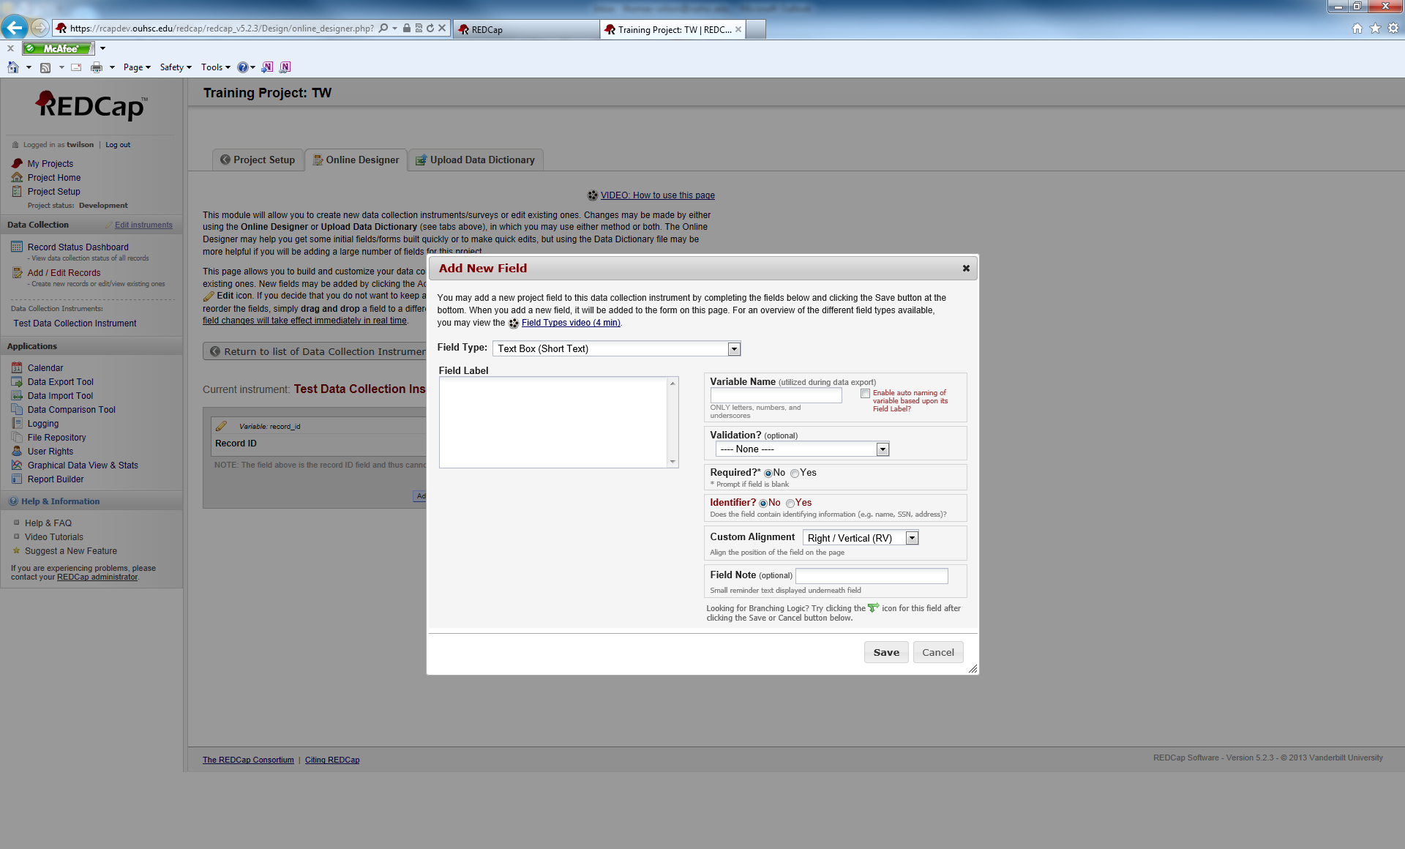

The first box to fill out is the Field Label. The field label is the text that the participant/user will see when working in REDCap.

Enter “Participant First Name” as the field label.

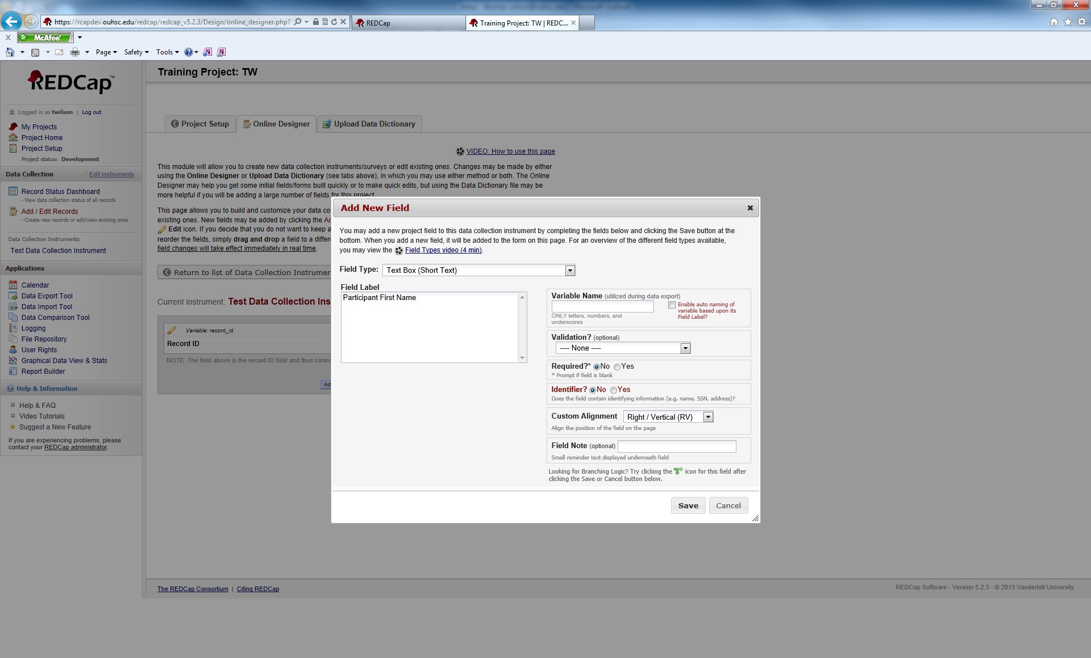

Next, we want to fill in the Variable Name. Underneat the text box for variable name, you will see a warning that says “ONLY letters, numbers, and underscores”. Those are the only characters you can use to name a variable. You may also see a checkbox to the right that says, “Enable auto naming of variable based upon its Field Label?”. If you choose this option, REDCap will automatically name your variables for you. It is convenient, but you have no control over the name. For now, we will leave that option unchecked and name the variables manually.

For the variable name enter, “first_name”.

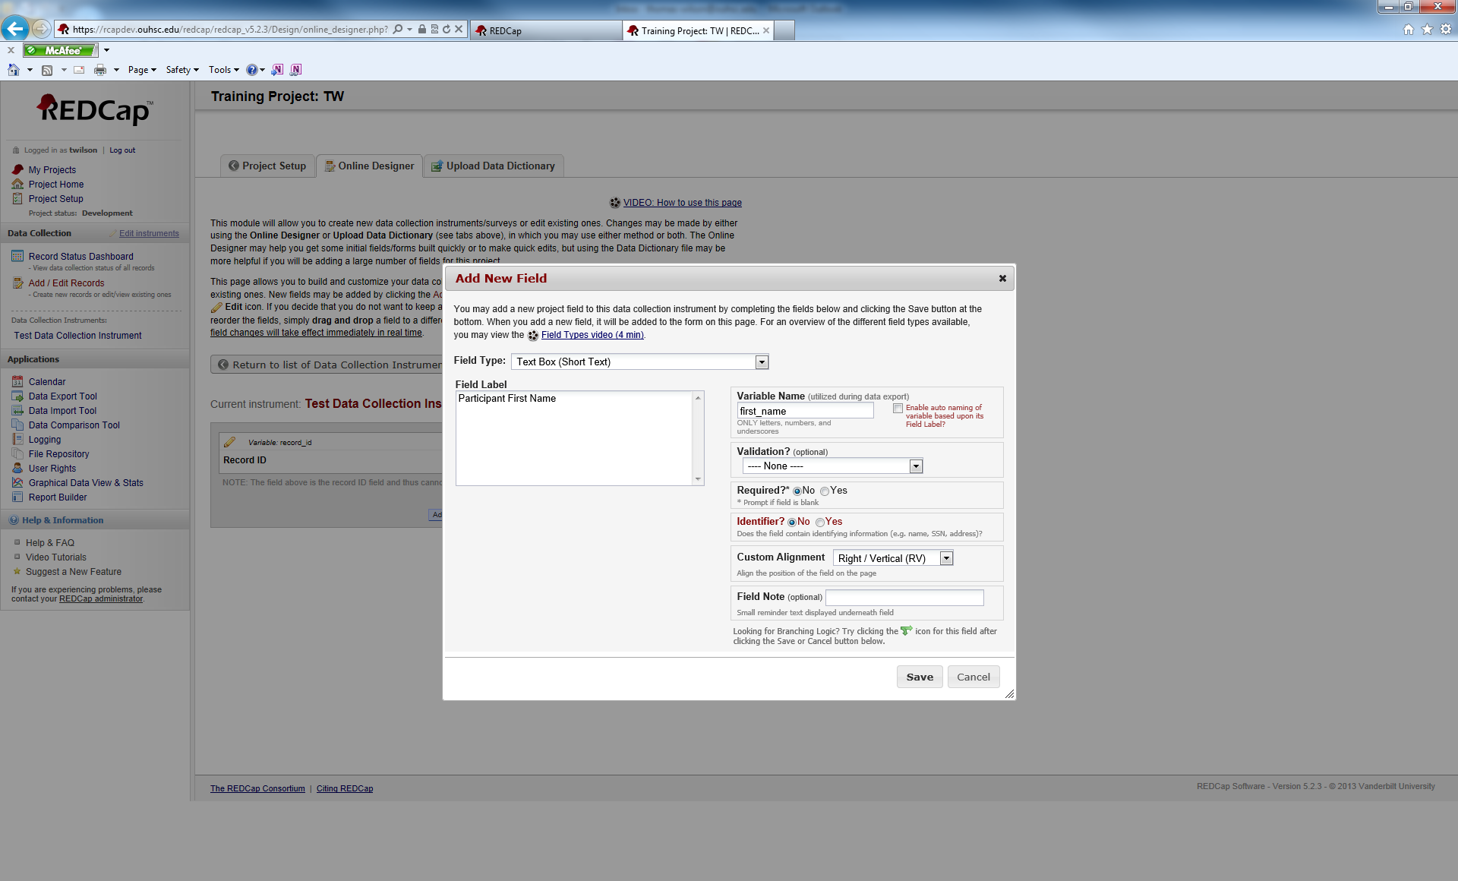

Underneath the variable name, you have an option called Validation?. Validation gives you the following choice:

Date (M-D-Y)

Date (Y-M-D)

Datetime (M-D-Y H:M)

Datetime (Y-M-D H:M)

Datetime w/ seconds (M-D-Y H:M:S)

Datetime w/seconds (Y-M-D H:M:S)

Email

Integer

Number

Phone U.S.

Time (HH:MM)

Zip Code

If you chose any of these options for a variable, the respondent/user will have to enter a value that matches the validation type.

You also have an option to make this a Required response and to mark whether or not the variable is an Identifier.

You have the option for Custom Alignment and adding a field note.

For training purposes, we will not select any of these options. Click save to create our new variable.

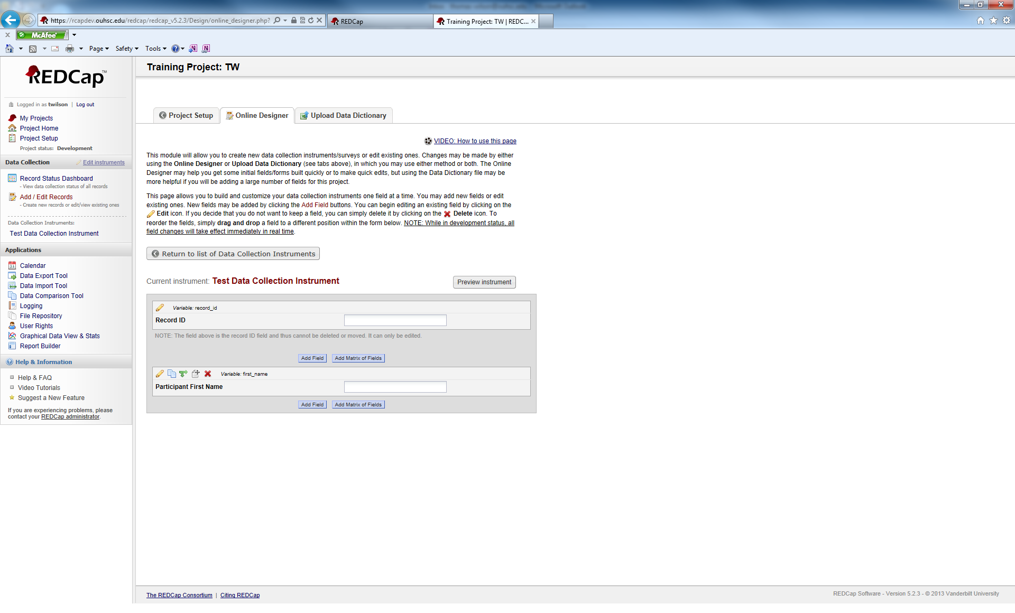

Your new variable will appear directly underneath the previous variable.